PRAKTIKUM SISTEM DIGITAL
DECODER



Disusun Oleh :
Fajar Indah Nur Azizah
L200200117
Kelas C

PROGRAM STUDI TEKNIK INFORMATIKA
FAKULTAS KOMUNIKASI DAN INFORMATIKA
UNIVERSIITAS MUHAMMADIYAH SURAKARTA
TAHUN 2020/2021

Setelah kegiatan selesai, lembar kerja ini dicetak (di-print) dan dikumpulkan ke asisten.  NIM : L200200117  Nama : Fajar Indah Nur Azizah  Nama Asisten : Shofiyah Nafisah, Danis Ardani  Tanggal Praktikum: 6 Juni 2021 | (Di isi oleh Asisten)  Nilai Praktek:  Tanda Tangan:

Percobaan 1. Membuat rangkaian decoder sederhana.
- Membuat decoder sederhana

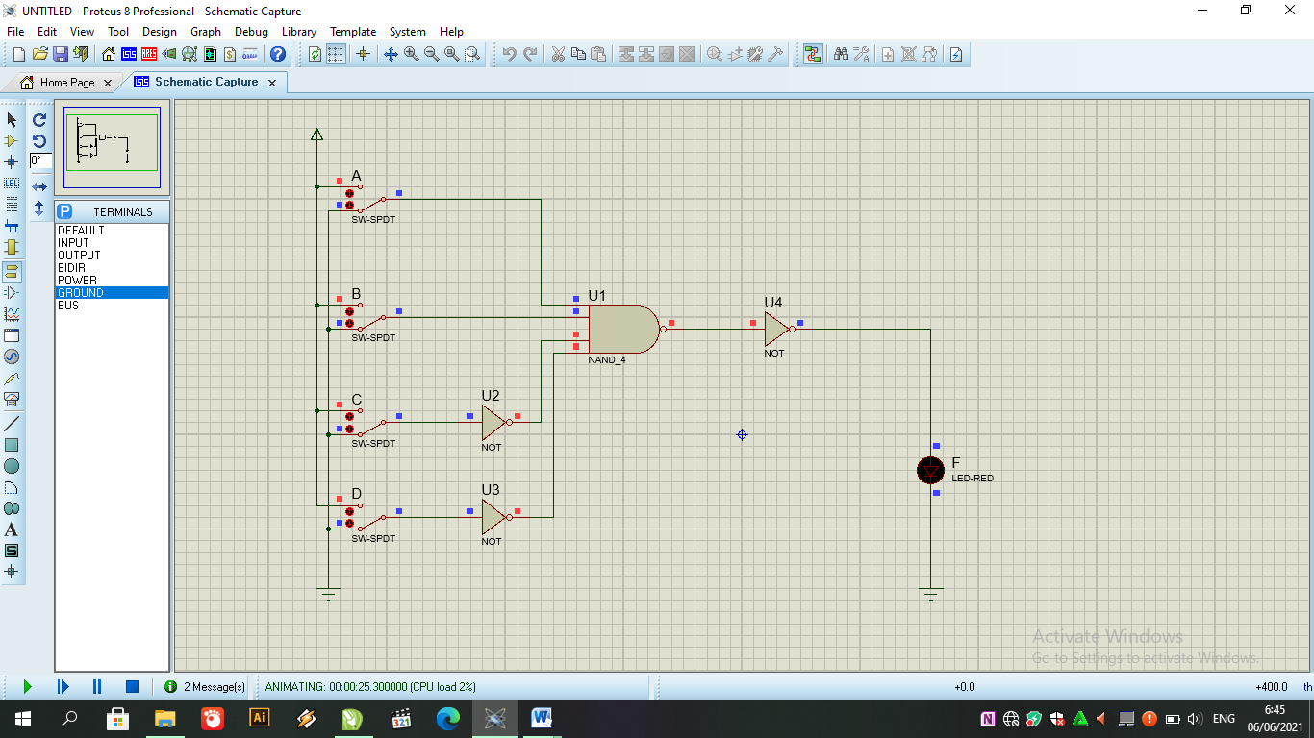

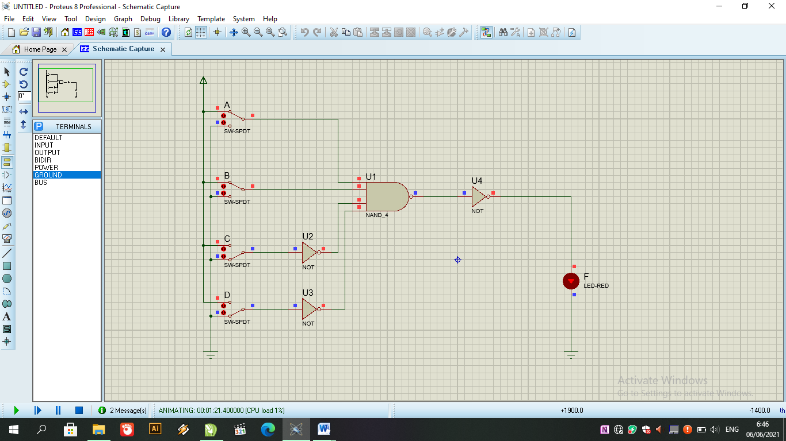

- Mengisi kolom kosong

NO | A | B | C | D | F
1 | 0 | 0 | 0 | 0 | 0
2 | 1 | 0 | 0 | 0 | 0
3 | 0 | 1 | 0 | 0 | 0
4 | 1 | 1 | 0 | 0 | 1
5 | 0 | 0 | 1 | 0 | 0
6 | 1 | 0 | 1 | 0 | 0
7 | 0 | 1 | 1 | 0 | 0
8 | 1 | 1 | 1 | 0 | 0
9 | 0 | 0 | 0 | 1 | 0
10 | 1 | 0 | 0 | 1 | 0
11 | 0 | 1 | 0 | 1 | 0
12 | 1 | 1 | 0 | 1 | 0
13 | 0 | 0 | 1 | 1 | 0
14 | 1 | 0 | 1 | 1 | 0
15 | 0 | 1 | 1 | 1 | 0
16 | 1 | 1 | 1 | 1 | 0

- Decoder (F) hanya bekerja (ON) ketika :
A = 1
B = 1
C = 0
D = 0

- Berdasarkan rangkaian dan tabel diatas, coba buat decoder yang mempunyai output sebagaimana fungsi decoder berikut :
F = 1, Jika kondisi A = 0, B= 1, C = 1, D = 1. (F = A’BCD)
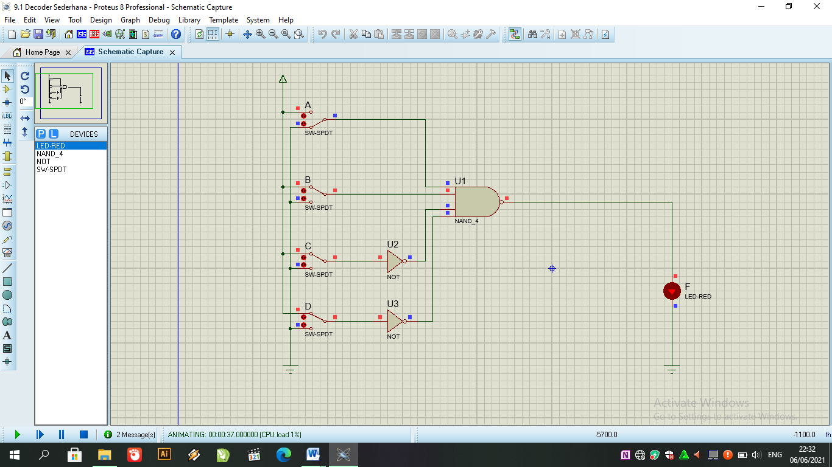

Percobaan 2.
- Membuat kombinasi gerbang logika

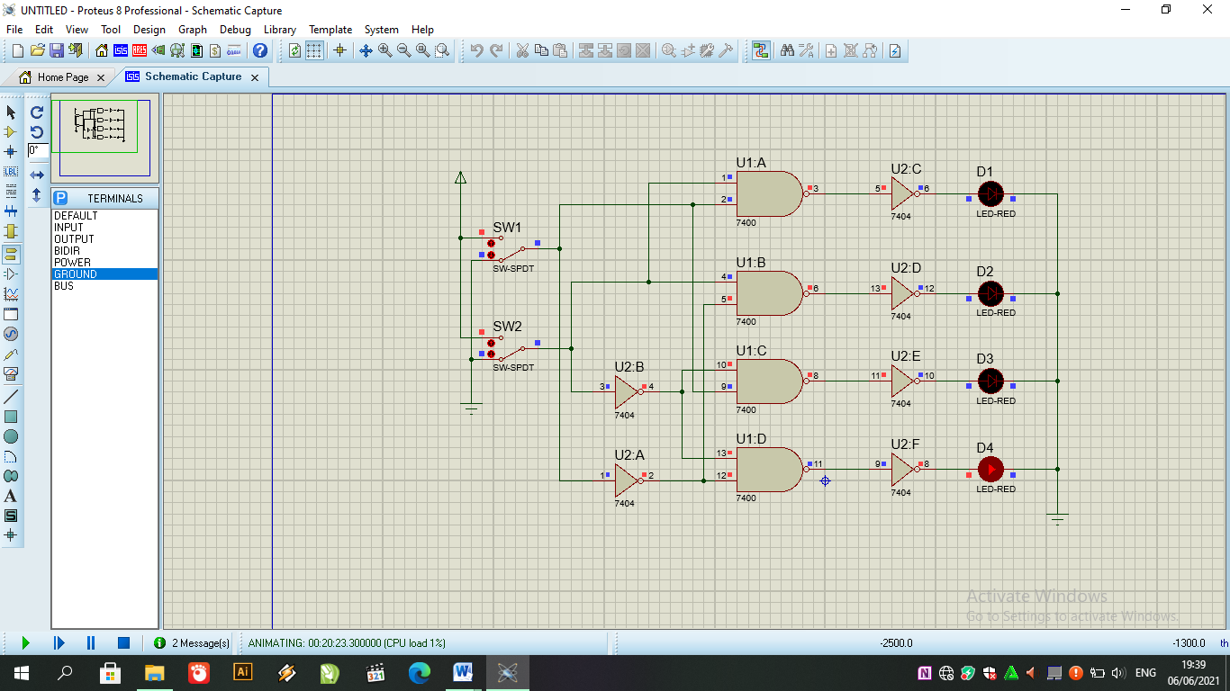
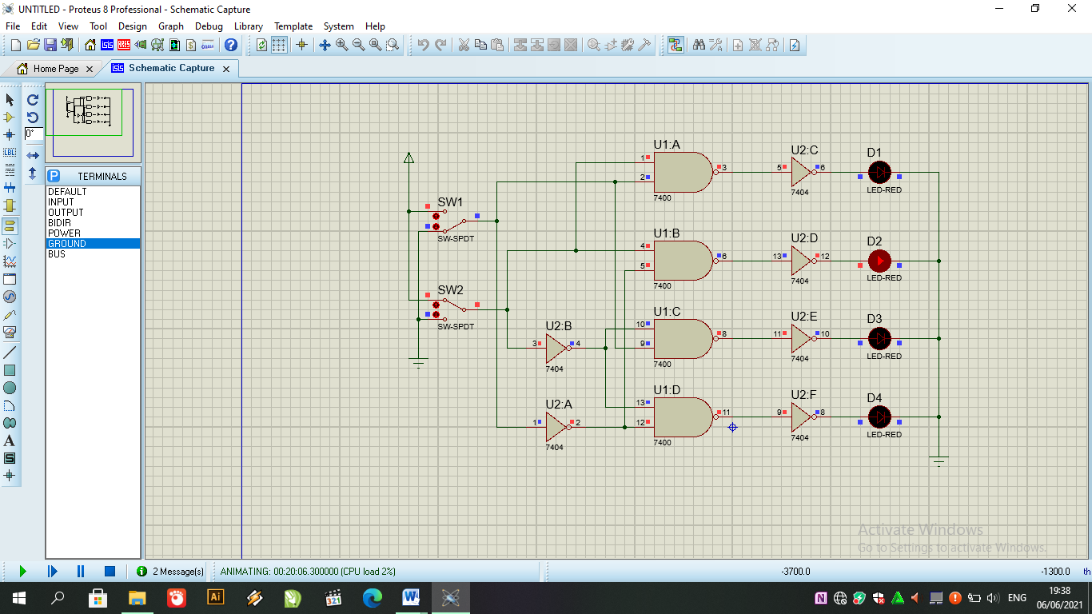

- Mengisi kolom kosong

Input |  | Output LED
SW1 | SW2 | D1 | D2 | D3 | D4
0 | 0 | 0 | 0 | 0 | 1
0 | 1 | 0 | 1 | 0 | 0
1 | 0 | 0 | 0 | 1 | 0
1 | 1 | 1 | 0 | 0 | 0

- Masing – masing diode (LED) menunjukkan hasil output dari rangkaian kombinasi :
D1 = SW1.SW2
D2 = SW1.SW2
D3 = SW1.SW2
D4 =SW1.SW2
Percobaan 3.
- Membuat kombinasi gerbang logika
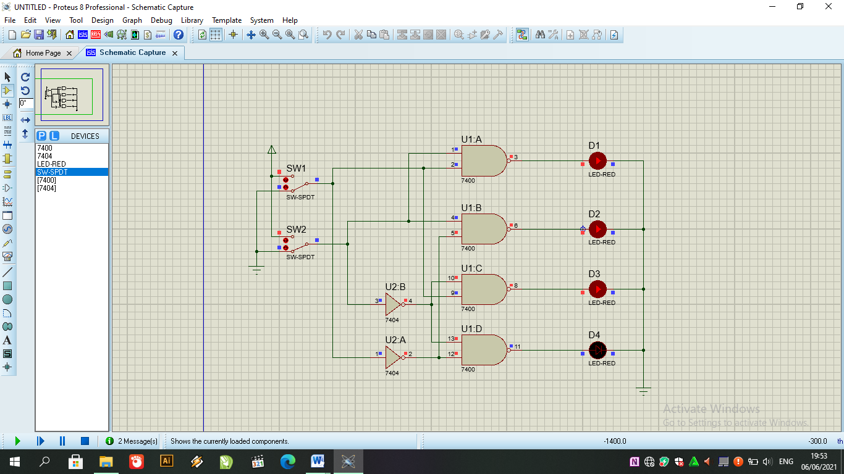

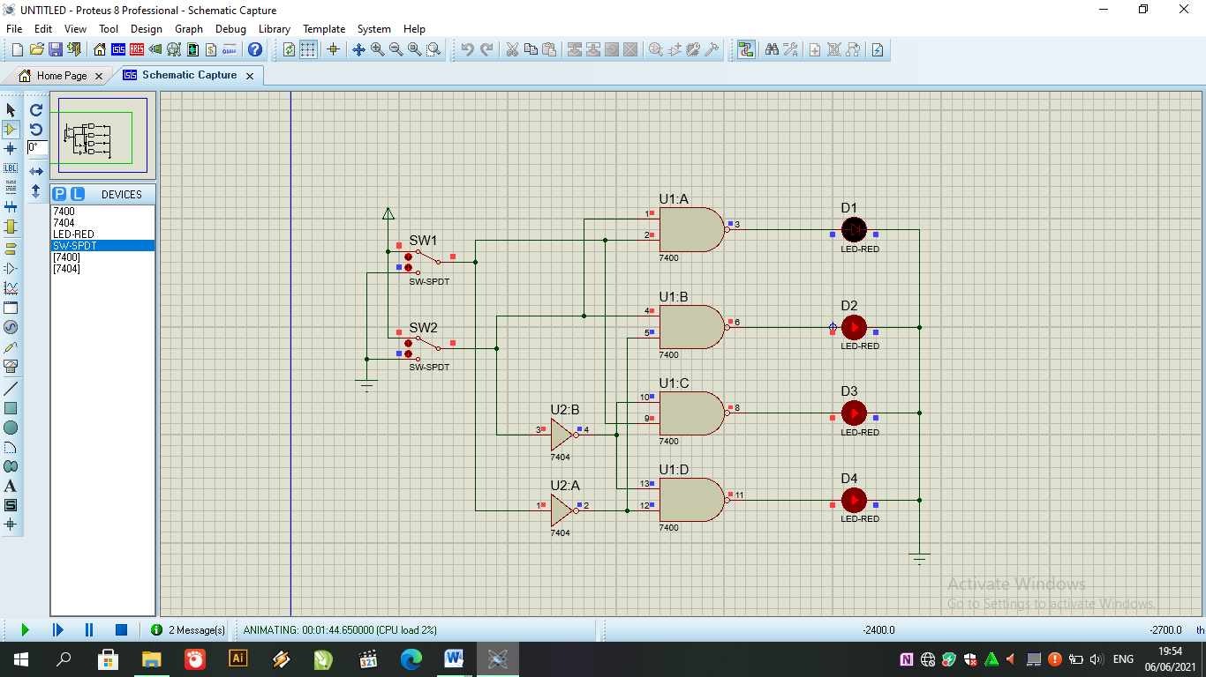

- Isi kolom kosong pada tabel

Input |  | Output LED
SW1 | SW2 | D1 | D2 | D3 | D4
0 | 0 | 1 | 1 | 1 | 0
0 | 1 | 1 | 0 | 1 | 1
1 | 0 | 1 | 1 | 0 | 1
1 | 1 | 0 | 1 | 1 | 1

- Masing – masing diode (LED) menunjukkan hasil output dari rangkaian kombinasi :
D1 = SW1.SW2
D2 = SW1.SW2
D3 = SW1.SW2
D4 =SW1.SW2

- Bandingkan hasil tabel kebenaran pada percobaan 2 dan percobaan 3! Buatlah kesimpulan
Pada percobaan 2 terdapat not sebelum led decoder, sedangkan percobaan 3 tidak ada not. karena itu menyebabkan perbedaan keluaran logic 1.

Percobaan 4. IC 7442 Decoder BCD-to-desimal
- Membuat rangkaian dengan menggunakan7442 (BCD to decimal decoder)

Common anode LED circuit
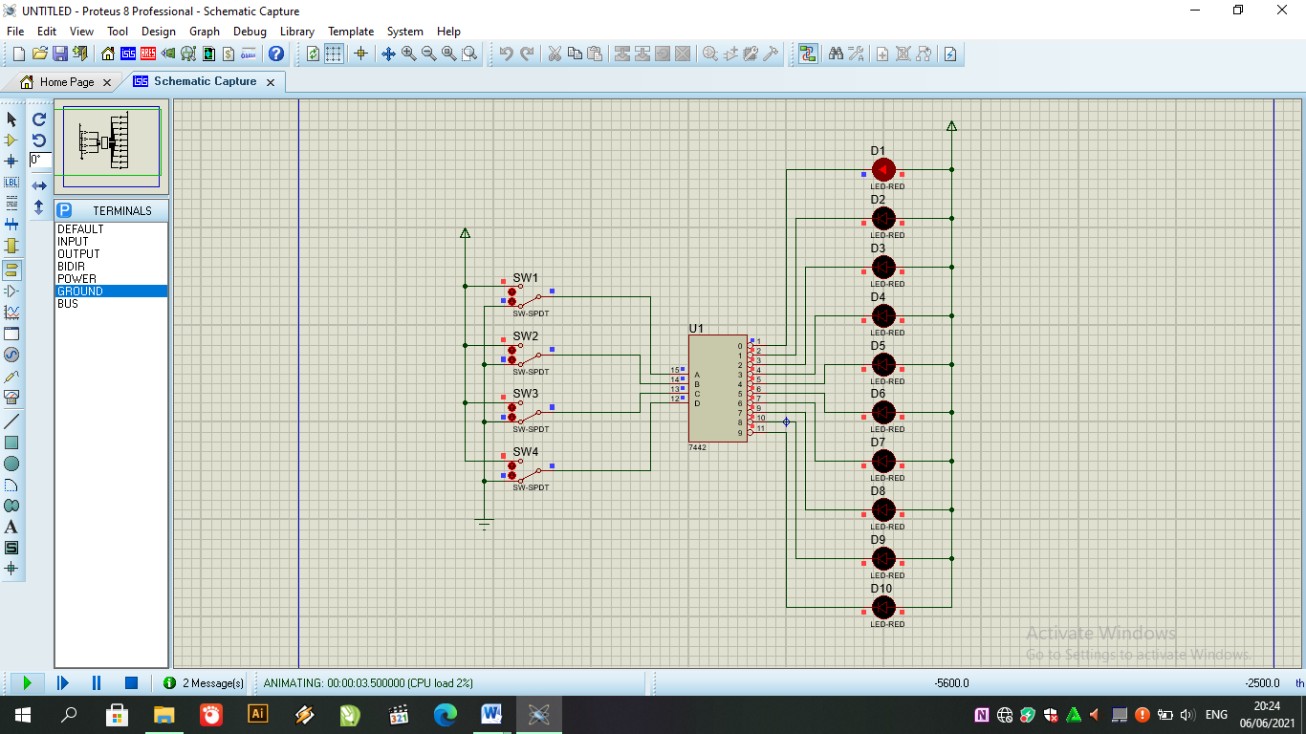

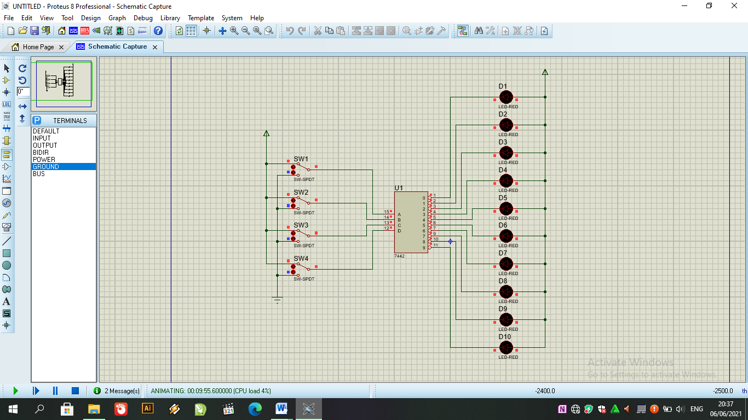

Common cathode LED circuit
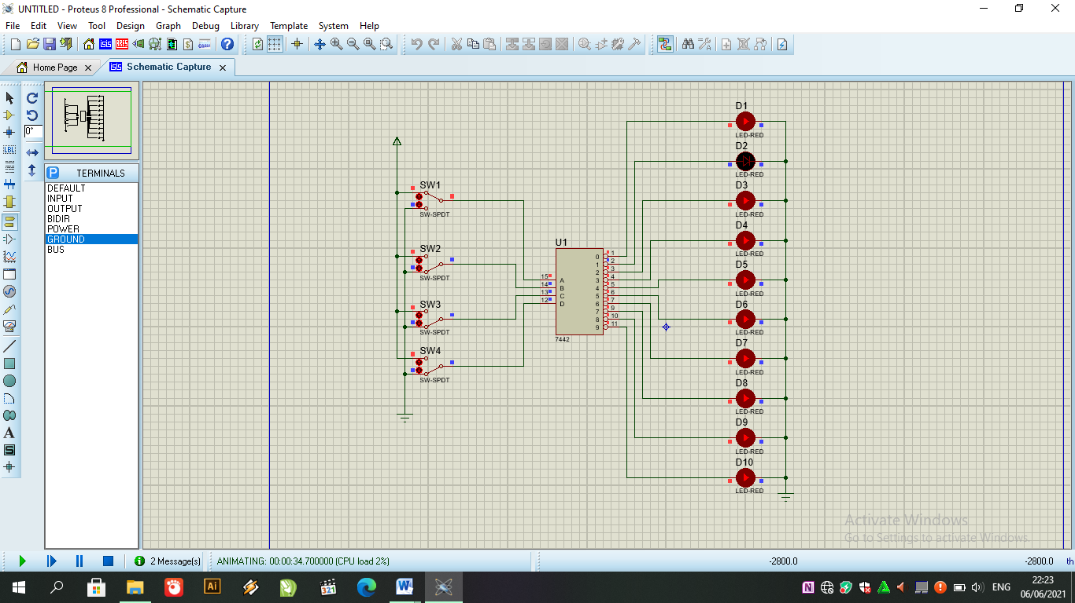

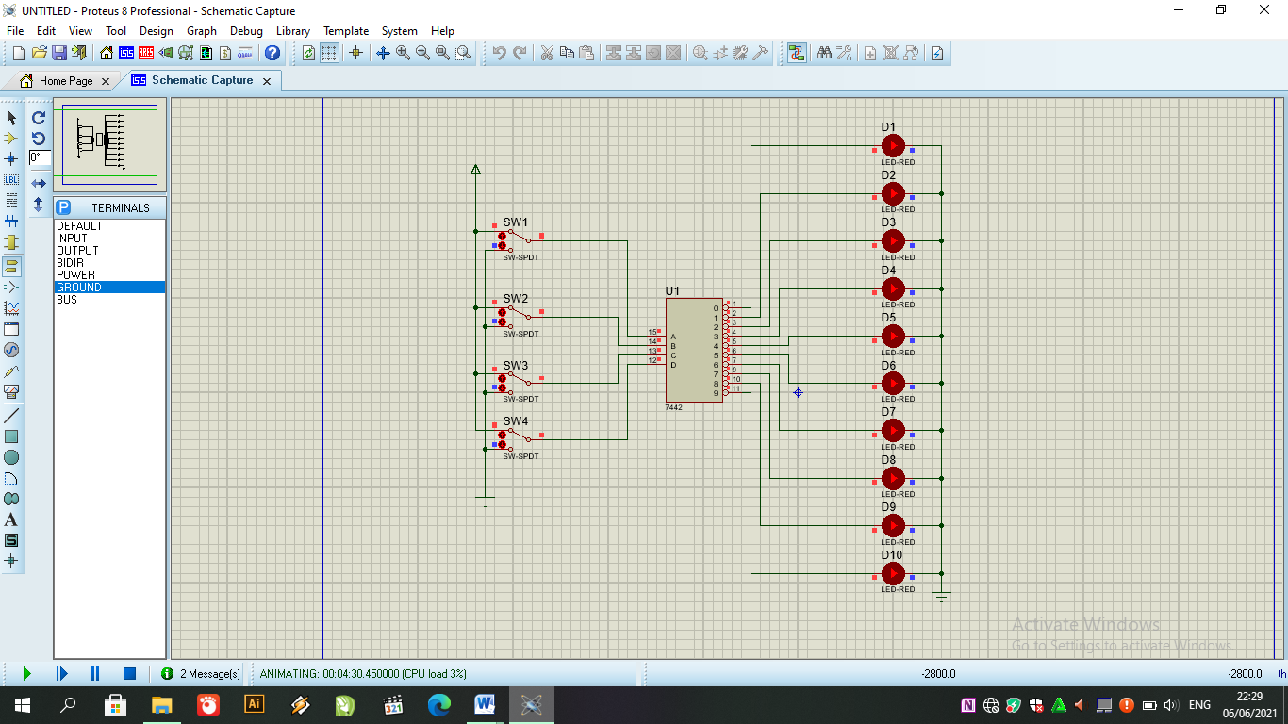

- Mengisi kolom kosong pada tabel kebenaran 7442

- Rangkaian common anode LED
NO | INPUT |  |  |  | OUTPUT
 | SW4 | SW3 | SW2 | SW1 | 0 | 1 | 2 | 3 | 4 | 5 | 6 | 7 | 8 | 9
1 | 0 | 0 | 0 | 0 | 1 | 0 | 0 | 0 | 0 | 0 | 0 | 0 | 0 | 0
2 | 0 | 0 | 0 | 1 | 0 | 1 | 0 | 0 | 0 | 0 | 0 | 0 | 0 | 0
3 | 0 | 0 | 1 | 0 | 0 | 0 | 1 | 0 | 0 | 0 | 0 | 0 | 0 | 0
4 | 0 | 0 | 1 | 1 | 0 | 0 | 0 | 1 | 0 | 0 | 0 | 0 | 0 | 0
5 | 0 | 1 | 0 | 0 | 0 | 0 | 0 | 0 | 1 | 0 | 0 | 0 | 0 | 0
6 | 0 | 1 | 0 | 1 | 0 | 0 | 0 | 0 | 0 | 1 | 0 | 0 | 0 | 0
7 | 0 | 1 | 1 | 0 | 0 | 0 | 0 | 0 | 0 | 0 | 1 | 0 | 0 | 0
8 | 0 | 1 | 1 | 1 | 0 | 0 | 0 | 0 | 0 | 0 | 0 | 1 | 0 | 0
9 | 1 | 0 | 0 | 0 | 0 | 0 | 0 | 0 | 0 | 0 | 0 | 0 | 1 | 0
10 | 1 | 0 | 0 | 1 | 0 | 0 | 0 | 0 | 0 | 0 | 0 | 0 | 0 | 1
11 | 1 | 0 | 1 | 0 | 0 | 0 | 0 | 0 | 0 | 0 | 0 | 0 | 0 | 0
12 | 1 | 0 | 1 | 1 | 0 | 0 | 0 | 0 | 0 | 0 | 0 | 0 | 0 | 0
13 | 1 | 1 | 0 | 0 | 0 | 0 | 0 | 0 | 0 | 0 | 0 | 0 | 0 | 0
14 | 1 | 1 | 0 | 1 | 0 | 0 | 0 | 0 | 0 | 0 | 0 | 0 | 0 | 0
15 | 1 | 1 | 1 | 0 | 0 | 0 | 0 | 0 | 0 | 0 | 0 | 0 | 0 | 0
16 | 1 | 1 | 1 | 1 | 0 | 0 | 0 | 0 | 0 | 0 | 0 | 0 | 0 | 0

- Rangkain common cathode LED

NO | INPUT |  |  |  | OUTPUT
 | SW4 | SW3 | SW2 | SW1 | 0 | 1 | 2 | 3 | 4 | 5 | 6 | 7 | 8 | 9
1 | 0 | 0 | 0 | 0 | 0 | 1 | 1 | 1 | 1 | 1 | 1 | 1 | 1 | 1
2 | 0 | 0 | 0 | 1 | 1 | 0 | 1 | 1 | 1 | 1 | 1 | 1 | 1 | 1
3 | 0 | 0 | 1 | 0 | 1 | 1 | 0 | 1 | 1 | 1 | 1 | 1 | 1 | 1
4 | 0 | 0 | 1 | 1 | 1 | 1 | 1 | 0 | 1 | 1 | 1 | 1 | 1 | 1
5 | 0 | 1 | 0 | 0 | 1 | 1 | 1 | 1 | 0 | 1 | 1 | 1 | 1 | 1
6 | 0 | 1 | 0 | 1 | 1 | 1 | 1 | 1 | 1 | 0 | 1 | 1 | 1 | 1
7 | 0 | 1 | 1 | 0 | 1 | 1 | 1 | 1 | 1 | 1 | 0 | 1 | 1 | 1
8 | 0 | 1 | 1 | 1 | 1 | 1 | 1 | 1 | 1 | 1 | 1 | 0 | 1 | 1
9 | 1 | 0 | 0 | 0 | 1 | 1 | 1 | 1 | 1 | 1 | 1 | 1 | 0 | 1
10 | 1 | 0 | 0 | 1 | 1 | 1 | 1 | 1 | 1 | 1 | 1 | 1 | 1 | 0
11 | 1 | 0 | 1 | 0 | 1 | 1 | 1 | 1 | 1 | 1 | 1 | 1 | 1 | 1
12 | 1 | 0 | 1 | 1 | 1 | 1 | 1 | 1 | 1 | 1 | 1 | 1 | 1 | 1
13 | 1 | 1 | 0 | 0 | 1 | 1 | 1 | 1 | 1 | 1 | 1 | 1 | 1 | 1
14 | 1 | 1 | 0 | 1 | 1 | 1 | 1 | 1 | 1 | 1 | 1 | 1 | 1 | 1
15 | 1 | 1 | 1 | 0 | 1 | 1 | 1 | 1 | 1 | 1 | 1 | 1 | 1 | 1
16 | 1 | 1 | 1 | 1 | 1 | 1 | 1 | 1 | 1 | 1 | 1 | 1 | 1 | 1

TUGAS
- Cari datasheet dari IC 7442! Cari schematic yang menunjukkan gerbang logika penyusunan IC 7442!
